### The Peach State Traveler

### tate Traveler

/

**Year 32, Issue 01 “FMCA PST Chapter Newsletter ~ January 2024**

**2024 Officers**

President: John Glen 404-281-3313

Vice President: Ed Gruba

Treasurer: Libba Gruba 770-365-6111

Secretary: Kenlyn Sawyer                              404-867-3898

National Director: Marvin Voyna                   678-472-4302

Alternate Natl. Director –

**2023 PST Appointees**

Wagon Master: Libba Gruba 770-365-6111

Sunshine Chair: Marge Esposito

Newsletter Editor: Patricia Voyna              678-523-0378

Directory Editor:

Membership Chair: Beth Bennett 404-317-1018

Chaplain: Jim Hollis 770-402-6074

**FMCA National Officers**

President – Rett Porter III

Sr V President – Gary Milner

Secretary – Kathie Balogh

Treasurer – Barbara Smith

**Future SEA (Southeast Area) Rally**

[www.seafmca.org](http://www.seafmca.org)

SEA President–Patricia Voyna email:

[pfvoyna@marvsdiesel.com](mailto:pfvoyna@marvsdiesel.com)

SEA Georgia VP – Marvin Voyna

February 7-10, 2024, SUN n FUN, Lakeland, Florida

**Future FMCA International Convention**

Winter 2024 – March 20-23, Tucson, AZ

* Summer 2024 – Redmond Oregon

Winter 2025 – March 12-15, Perry, GA

Summer 2027 – July 14-17, Gillette, WY

*\* = Contingent on successful contract negotiations*

*.*

**2024 RALLY HOSTS**

Wagon Master – Libba Gruba

* Weekend different from 1st weekend.

**Special rally due to distance from Atlanta

###Our Bylaws require members to host a rally. Ideally, three couples should be able to manage a great rally weekend.

**PEACHSTATE TRAVELERS 2024 RALLY SCHEDULE**

**DATE HOST/CO-HOST CAMPGROUND / LUNCHEON LOCATION**

FRIDAY- FEB 2-4 Mallory 678-313- 3508 Luncheon Kani House -Dawsonville 1:00 pm 205 Dawson Village Way

MARCH 1-3 Sawyers /VanGys 404-867-3898 Leisure Acres - Cleveland 3840 Westmoreland Rd 706-865-6466

APRIL 5-7 Hollis 770-354- 6673 Great Outdoors - Franklin NC 321 Thumpers Trail 828-518-6117

MAY 3-5 Bowman 770-880- 2151 River Rock - Gadsen AL 1 Riverview Ln 256- 543-7111

JUNE 7-9 Castor/Jones 404- 625-5402 Creekside RV Resort - Savannah 275 Fort Argyle Rd 915-897-2855

JULY 5-7 Gruba/Bennett 770- 365-6111 Forsyth KOA Journey - Forsyth 414 S Frontage RD 800-562-8614 LISA

AUG 2-4 Espositos

SEPT 6-8 Glenn 404-626- 5605 River Ridge Retreat -Guntersville AL 2450 Monsanto Rd 256-505-1454

OCT 4-6 Cowan

NOV 1-3 Simons 678-557- 7599

DEC 6-8 Club Officers NOTES: Always let the host know that you will be attending



**PRESIDENTS CORNER – January 2024**

By John Glen

**NATIONAL DIRECTOR REPORT**

By Marvin Voyna

**SECRETARY REPORT- January 2024**

By Kenlyn Sawyer

The January Luncheon was held at the Mad Italian Restaurant in Chamblee, GA on January 6, 2024. The hosts were Alan and Debbi Simons. There was a total of 17 people. The names of those in attendance are at the end of this report.

President John Glen opened the meeting on Saturday, January 7, 2024, by thanking the hosts for the luncheon and welcoming all attendees.

Treasurer Libba Gruba reported the received 2024 dues have been deposited in the bank. She is continuing to follow up on a few missing dues.

Wagon Master, Libba Gruba passed out the current list of 2024 rally hosts and location. Please contact the hosts to confirm your attendance after the campground reservations are made.

February 3 - Luncheon – Kani House – 205 Dawson Village Way, Dawsonville, GA – Lovena & Cecil Mallory – 678-313-3508

March 1 - 3 - Leisure Acres – 3840 Westmoreland Road, Cleveland, GA – 706-865-6466 – Sawyers 404-867-3898/VanGys

April 5 – 7 - The Great Outdoors RV Resort – 321 Thumpers Trail, Franklin, NC – Jim & Jan Hollis – 770-354-6673

May 3 – 5 - River Rocks Landing - 1 Riverview Lane, Gadsden, AL – Wiley Bowman – 770-880-2151

June 7 - 9 - CreekFire RV Resort – 2275 Fort Argyle Rd, Savannah, GA – Ron & Linda Castor/Teri Jones 404-625-5402

July 5 - 7 - Forsyth KOA Journey – 414 S Frontage Road, Forsyth, GA – Ed & Libba Gruba 770-365-6111/Beth Bennett

Kenlyn announced flyer/agenda for Leisure Acres will be sent out within the next week, please get your reservations in with the campground and let her know if you will be camping/driving up for the weekend.

President Glenn announced a Wagon Master will be need, please let him know if you are interested to step up for this position.

Treasurer Libba Gruba announced that deposits have been made for dues that have been paid. She is following up with members that have not paid their 2024 dues. She is also working with the Bank and Kenlyn to update the new Treasurer information.

Don’t forget to pay your 2024 dues to Libba Gruba.

Please continue to keep our members/alumnae that have been facing health challenges in our prayers including Doug Ralston, Patricia & Marvin Voyna, Al & Mary Ann Miller, Libba Gruba, Donna Loudermilk, Bobby & Brenda Moreman, John & Nancye Glenn, Boyd Carlyle, Beth Bennett, and Jim Watson.

Bill Esposito made a motion to close the meeting and Don Loudermilk seconded.

MEMBERS: Buchanan; Esposito; Glenn; Gruba; Loudermilk; Bobby Moreman; Kenlyn Sawyer; Simons. Van Gys; Voyna

GUEST: Robin Robboy

**SECRETARY REPORT- June 2023**

By Kenlyn Sawyer

The June 2023 Rally was held at the Holiday Travel Park in Rossville, GA on June 2 - 4, 2023. Alan and Debbi Simons were hosts for the weekend. There was a total of 11 people camping for the weekend. The names of those in attendance are at the end of this report.

There was no meeting held this weekend just a time for announcements.

Continue to keep our members that have been facing health challenges in our prayers including the Moremans, Nancye Glenn and Boyd Carlyle.

Please contact your hosts to confirm your attendance after the campground reservations are made.

July 8, 2023 1 PM - Luncheon The Kani House – 205 Dawsonville Village Way South, Dawsonville, GA – Carlyle

August 4-6, 2023 - Talona Ridge (Hawk Valley), Ellijay, GA – Esposito

September 8-10, 2023 - Premiere RV Campground – Atlanta Motor Speedway – No Host/Sawyer

October 6-8, 2023 – Twin Oaks RV Park, Elko, GA – Glenn

November 3-5, 2023 - High Falls State Park, Jackson, GA – Cooke

December 1-3, 2023 - Location TBD – PST Officers

MEMBERS: Bennett; Bowman; Current; Gruba; Esposito; Sawyer; Simons

**SECRETARY REPORT- July 2023**

By Kenlyn Sawyer

The July 2023 Luncheon was held at the Kani House Restaurant in Dawsonville, GA on July 8, 2023. Boyd and Terry Carlyle were the hosts for the weekend. There was a total of 31 people for the luncheon. The names of those in attendance are at the end of this report.

President Terri Jones opened the meeting welcoming all of the members and past members and guests that were in attendance. President Jones also thanked Terry and Boyd for making the arrangements for the luncheon. President Jones made an announcement that PST officer elections will be coming up soon. She is contacting people to the nominating committee now.

Please contact your hosts to confirm your attendance after the campground reservations are made.

August 4-6, 2023-Talona Ridge (Hawk Valley) Ellijay, GA Esposito

September 8-10, 2023 - Premiere RV Campground – Atlanta Motor Speedway – No Host/Sawyer

October 6-8, 2023 – Twin Oaks RV Park, Elko, GA – Glenn

November 3-5, 2023 - High Falls State Park, Jackson, GA – Cooke

December 1-3, 2023 - Location TBD – PST Officers

Wagon Master, Libba Gruba, made an announcement about filling the months for 2024 rallies so that the rallies and contacts can be printed in the FMCA Magazine for 2024.

Continue to keep our members that have been facing health challenges in our prayers including the Moremans, Nancye Glenn and Boyd Carlyle.

MEMBERS: Bennett; Bowman; Buchanan: Carlyle; Castor; Esposito; Glen; Gruba; Hollis; Jones; Rankins; Sawyer; Simons

ALUM: John & Susie Hamilton; Cecil & Lovena Mallory; Doug & Brenda Ralston; Pauline Wood

GUESTS: Joel and Linda Ash

**SECRETARY REPORT- August 2023**

By Kenlyn Sawyer

The August 2023 Rally was held at the Talona Ridge RV Resort in Ellijay, GA on August 4-6, 2023. Bill and Margie Esposito were the hosts for the weekend. There was a total of 15 people for the weekend. The names of those in attendance are at the end of this report.

President Terri Jones opened the meeting on Saturday, August 5, 2023, at the Esposito/Sawyer buddy site welcoming all the members that were in attendance. President Jones also thanked Bill and Margie for making the arrangements for the rally.

President Jones reminded everyone that rally fees are due to the hosts even if you cancel out of the rally the week of the rally. Most hosts have started buying for the rally prior to the week of the rally and should be reimbursed for their expenses. Due to legal issues, alcohol cannot be purchased as expenses for a rally or prize. Personal use of alcohol is ok.

President Jones made an announcement that PST officer elections will be coming up soon.

Please contact your hosts to confirm your attendance after the campground reservations are made.

September 8-10, 2023 - Premiere RV Campground – Atlanta Motor Speedway – No Host/Sawyer

October 6-8, 2023 – Twin Oaks RV Park, Elko, GA – Glenn

November 3-5, 2023 - High Falls State Park, Jackson, GA – Cooke

December 1-3, 2023 - Location TBD – PST Officers

Wagon Master, Libba Gruba, passed out the latest 2024 rally listing. She is trying to fill all the months for 2024 so that the rallies and contacts can be printed in the FMCA Magazine for 2024.

Continue to keep our members that have been facing health challenges in our prayers including Doug Ralston, Pat & Marvin Voyna, Al & Mary Ann Miller, Libba Gruba, Bobby & Brenda Moremans, John & Nancye Glenn, Boyd Carlyle and Jim Watson.

The nominating committee members will be Debbi Simons, Wiley Bowman, Terri Jones, Ed Gruba and Nancye Glen.

MEMBERS: Bennett; Bowman; Castor; Cowan; Esposito; Gruba; Jones; Sawyer; Simon

**SECRETARY REPORT- September 2023**

By Kenlyn Sawyer

The September 2023 Rally was held at the Premiere RV Campground at the Atlanta Motor Speedway in Hampton, GA on September 8 -10, 2023. This was a “No Host/No Frills” Weekend. There was a total of 8 people for the weekend. The names of those in attendance are at the end of this report.

President Terri Jones opened the meeting on Friday, September 8 at the Cooke camp site.

President Jones made an announcement that PST officer elections will be coming up soon. The nominating committee members will be Debbi Simons, Wiley Bowman, Terri Jones, Ed Gruba and Nancye Glen.

Please contact your hosts to confirm your attendance after the campground reservations are made.

October 6-8, 2023 – Twin Oaks RV Park, Elko, GA – Glenn

November 3-5, 2023 - High Falls State Park, Jackson, GA – Cooke

December 1-3, 2023 - Location TBD – PST Officers

Wagon Master, Libba Gruba, made an announcement that all months are filled for 2024 out the latest 2024 rally listing. She is trying to fill all the months for 2024 so that the rallies and contacts can be printed in the FMCA Magazine for 2024.

Continue to keep our members/alumnae that have been facing health challenges in our prayers including Doug Ralston, Pat & Marvin Voyna, Al & Mary Ann Miller, Libba Gruba, Bobby & Brenda Moremans, John & Nancye Glenn, Boyd Carlyle and Jim Watson.

MEMBERS: Bennett; Cooke; Gruba; Jones; Sawyer;

ALUM for Dinner: Ted and Darlene Young

GUEST: Greyson Young

**SECRETARY REPORT- October 2023**

By Kenlyn Sawyer

The October 2023 Rally was held at the Twin Oaks RV Park in Elko, GA on October 6 - 8, 2023. The hosts were John and Nancye Glenn. There was a total of 11 people for the weekend. The names of those in attendance are at the end of this report.

President Terri Jones opened the meeting on Friday, October 7 at the clubhouse and thanked the hosts for the weekend.

Please contact your hosts to confirm your attendance after the campground reservations are made.

October 6-8, 2023 – Twin Oaks RV Park, Elko, GA – Glenn

November 3-5, 2023 - High Falls State Park, Jackson, GA – Cooke

December 1-3, 2023 - Location TBD – PST Officers

Wagon Master, Libba Gruba, made an announcement that all months are filled for 2024rally hosts. She is trying to fill all the months for 2024 so that the rallies and contacts can be printed in the FMCA Magazine for 2024. Make your reservations now and let the hosts know.

The nominating committee make the announcements of the 2024 – 2025 PST Officers.

President – John Glenn

Vice President – Ed Gruba

Treasurer – Terry Carlyle or Libba Gruba if Terry won’t do it.

Secretary – Kenlyn Sawyer

Wiley moved to close nominations and Libba seconded.

Don’t forget to pay your 2024 dues at the December 2, 2023 luncheon.

Please continue to keep our members/alumnae that have been facing health challenges in our prayers including Doug Ralston, Pat & Marvin Voyna, Al & Mary Ann Miller, Libba Gruba, Bobby & Brenda Moremans, John & Nancye Glenn, Boyd Carlyle and Jim Watson.

MEMBERS: Bennett; Bowman; Cooke; Glenn; Gruba; Jones; Sawyer.

**SECRETARY REPORT- November 2023**

By Kenlyn Sawyer

The November 2023 Rally was held at the High Falls State Park in Jackson, GA on November 3 - 5, 2023. The hosts were TJ and Ginny Cooke. There was a total of 8 people for the weekend. The names of those in attendance are at the end of this report.

President Terri Jones opened the meeting via phone on Saturday, November 4, 2023, at the Cooke’s campsite and thanked the hosts for the weekend.

Please contact your hosts to confirm your attendance after the campground reservations are made.

December 2, 2023, 2PM – Crossroad Bar & Grill – Flowery Branch, GA – PST Officers

December 1 – 3, 2023 – Don Carter State Park, Gainesville, GA

Wagon Master, Libba Gruba, made an announcement that all months are filled for 2024 rally hosts. She is trying to fill all the months for 2024 so that the rallies and contacts can be printed in the FMCA Magazine for 2024. Make your reservations now and let the hosts know.

Wiley made the announcement that the ballots were received and the results for the 2024 – 2025 PST Officers.

President – John Glenn

Vice President – Ed Gruba

Treasurer – Libba Gruba

Secretary – Kenlyn Sawyer

Don’t forget to pay your 2024 dues at the December 2, 2023, luncheon.

Please continue to keep our members/alumnae that have been facing health challenges in our prayers including Doug Ralston, Pat & Marvin Voyna, Al & Mary Ann Miller, Libba Gruba, Bobby & Brenda Moreman, John & Nancye Glenn, Boyd Carlyle, Beth Bennet and Jim Watson.

MEMBERS: Bowman; Cooke; Sawyer; Simons.

GUEST: Dollie Babb

**SECRETARY REPORT- December 2023**

By Kenlyn Sawyer

The December Luncheon was held at the Crossroad Bar and Grill in Flowery Branch, GA on December 2, 2023. The hosts were the 2023 PST Officers: Terri Jones, Terry Carlyle and Kenlyn Sawyer. Three RV’s camped at Don Carter State Park in Gainesville, GA. There was a total of 22 people for the luncheon/weekend. The names of those in attendance are at the end of this report.

President Terri Jones opened the meeting via phone on Saturday, December 2, 2023, at the Crossroad Bar and Grill Restaurant in Gainesville, GA by thanking Terry Carlye for arranging the restaurant and welcoming all attendees.

Treasurer Terry Carlyle provided the Treasure Report for December 2023.

Beginning Balance – 02-01-2023 $2,728.38

Receipts:

December 2022 Rally 2.08

March 2023 Rally 6.00

April 2023 Rally 4.12

May 2023 Rally 2.00

New Member 45.00

Dues 30.00

August Rally 44.05

October Rally 6.64

Disbursements:

President Gift 75.00

Ending Balance 12-01-2023 $2,793.27

President Jones called the 2024 PST Officers forward to be sworn in for the 2024-2025 term.

President – John Glenn

Vice President – Ed Gruba

Treasurer – Libba Gruba

Secretary – Kenlyn Sawyer

National Director – Marvin Voyna

Wagon Master, Libba Gruba, made an announcement that all months are filled for 2024 rally hosts. She is trying to fill all the months with hosts and campgrounds for 2024 so that the rally locations and contacts can be printed in the FMCA Magazine for 2024. Please contact your hosts to confirm your attendance after the campground reservations are made.

January 6 - Luncheon – Mad Italian - 2089 Savoy Dr, Chamblee, GA – Alan & Debbi Simons – 678-557-7599

February 3 - Luncheon – Kani House – 205 Dawson Village Way, Dawsonville, GA – Lovena & Cecil Mallory – 678-313-3508

March 1 - 3 - Leisure Acres – 3840 Westmoreland Road, Cleveland, GA – 706-865-6466 – Sawyers 404-867-3898/VanGys

April 5 – 7 - The Great Outdoors RV Resort – 321 Thumpers Trail, Franklin, NC – Jim & Jan Hollis – 770-354-6673

May 3 – 5 - River Rocks Landing - 1 Riverview Lane, Gadsden, AL – Wiley Bowman – 770-880-2151

June 7 - 9 - Creekside RV Resort – 2275 Fort Argyle Rd, Savannah, GA – Ron & Linda Castor/Teri Jones 404-625-5402

July 5 - 7 - Forsyth KOA Journey – 414 S Frontage Road, Forsyth, GA – Ed & Libba Gruba 770-365-6111/Beth Bennett

Don’t forget to pay your 2024 dues to Libba Gruba.

Please continue to keep our members/alumnae that have been facing health challenges in our prayers including Doug Ralston, Patricia & Marvin Voyna, Al & Mary Ann Miller, Libba Gruba, Donna Loudermilk, Bobby & Brenda Moreman, John & Nancye Glenn, Boyd Carlyle, Beth Bennett, and Jim Watson.

The meeting ended with wishing everyone a Merry Christmas and Happy New Year.

MEMBERS: Bennett; Bowman; Buchanan; Carlyle; Esposito; Glenn; Gruba; Loudermilk; Sawyer; Simons. Voyna

CAMPING: Bowman; Buchanan; Sawyer

ALUM: Doug and Brenda Ralston

GUEST: Dollie Babb

**RALLY REPORT – January 2024**

By Alan and Debbi Simons

**SUNSHINE REPORT – January 2024**

By

**7-7-2023**

As some of you heard over the weekend, we lost a fellow RV friend and former PST member, Barb Watson on Thursday, July 13, 2023 unexpectedly.  Please keep Jim and their family in your prayers in the coming days and months to follow.

<https://www.iviefuneralhome.com/obituaries/Barbara-Barb-Ann-Watson?obId=28447020&fbclid=IwAR23XQyyvvMVfdkXT1a4tR5X1L-wUZ-dQz4tRljkYEoRTGOYu8CL1aKH30M#/obituaryInfo>

](https://www.iviefuneralhome.com/obituaries/Barbara-Barb-Ann-Watson?obId=28447020&fbclid=IwAR23XQyyvvMVfdkXT1a4tR5X1L-wUZ-dQz4tRljkYEoRTGOYu8CL1aKH30M#/obituaryInfo)[Obituary information for Barbara "Barb" Anne Watson](https://www.iviefuneralhome.com/obituaries/Barbara-Barb-Ann-Watson?obId=28447020&fbclid=IwAR23XQyyvvMVfdkXT1a4tR5X1L-wUZ-dQz4tRljkYEoRTGOYu8CL1aKH30M#/obituaryInfo)

View Barbara "Barb" Anne Watson's obituary, contribute to their memorial, see their funeral service details, and more.

www.iviefuneralhom

Jim's address: Jim Watson

4167 Downings Creek Rd Hayesville, NC 30534

**10-14-2023**

We have moved into Holbrook.  We will be selling our home soon.  I do not know if you were aware that Wayne had surgery - doing great now - and on our Anniversary cruise, I fell and required 2 stitches to my head.  Upon return had Dr. physical appt and sent to hospital because vitals so low, they gave me last rights - something happened and I was able to get a pace maker !  Surprise as never ever had heart issues.  God is good.

We are at 13682 Hwy 92, Woodstock, GA 30188.  Apt 3022.

**11-16-2023**

I just received this note from Wanda - please keep her and Wayne in your prayers for her recent health challenges.  They were both such a vital part of our club and Funseekers for many years. Her new address is in the email I sent earlier today.

I have been moved from ICU and am in NHC 10212,  I am dealing with Covid and my Heart pacemaker?  All a shock!  Wayne and I had to sell our home and are in Holbrook now.  Neal is here now so have help with decisions and our next step.  Prayers requested and will update when know what is next. Many fond memories with PST keeps me happy and gives me strength.  Wanda

**11-23-2023**

Please keep Donna Loudermilk in your prayers for continued healing.  She was hospitalized in Florida for the past week with respiratory issues. She was dismissed on Wednesday and got home in the wee hours of Thanksgiving day.

**TREASURES’S REPORT February 2023**

By: Terry Carlyle

**Beginning Balance 03-07-2022 $2,549.45**

Receipts:

May Rally 30.85

Sept. Rally 7.08

Jan. Rally 7.00

Anniversary FMCA 150.00

New Member 15.00

Dues 200.00

Disbursements:

Signs 159.00

Stamps for Sunshine 72.00

**Ending Balance 02-01-2023 $2,728.38**

*EVERYONE MUST COMPLETE A RALLY REPORT AND SEND TO ME FOR THEIR RALLY.*

*PLEASE SEND ALL RECEIPTS WITH IT!!!!!.3*

**Birthdays**

1-20 - Beth Bennett

1-30 - Margie Esposito

**Anniversaries**

**Directory Corrections**

Please see Dennis' Buchanan below regarding the corrections for his profile.

His birthday is September 19.  He also upgraded his motorhome to a 2022 Entegra Aspire. He is also starting to use a new email, DBuch1938@gmail.com more. Can you please update your records.



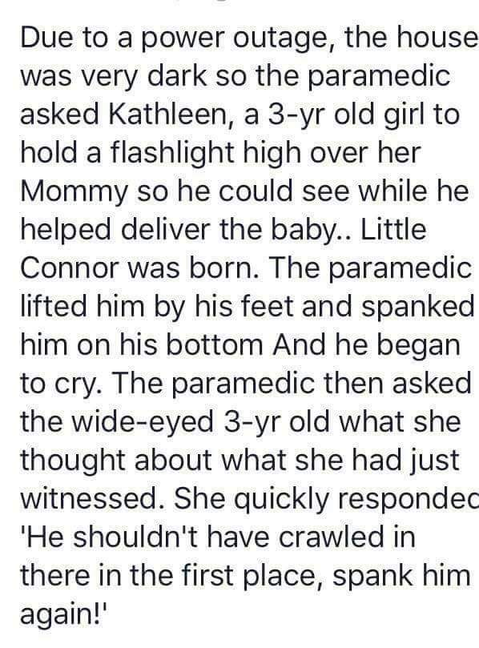

[**A divine sense of time and currency**](https://jokesfunnystories.quora.com/A-divine-sense-of-time-and-currency)

A guy said to God:

*"God, is it true that to you a billion years is like a second?"*

God said yes.

The guy said:

*"God, is it true that to you a billion dollars is like a penny?"*

God said yes.

The guy said:

*"God, can I have a penny?"*

God said:

*"Sure, just a second."*

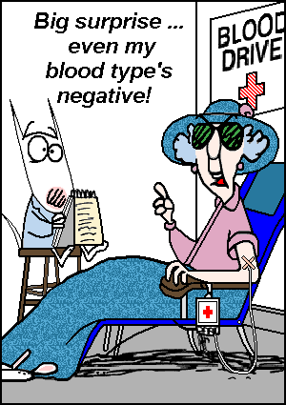

**You think English is easy??**

I think this retired English teacher was bored...This took a lot of work to put together!

1) The bandage was wound around the wound.

2) The farm was used to produce produce.

3) The dump was so full that it had to refuse more refuse.

4) We must polish the Polish furniture..

5) He could lead, if he would get the lead out.

6) The soldier decided to desert his dessert in the desert..

7) Since there is no time like the present, he thought it was time to present the present.

8) A bass was painted on the head of the bass drum.

9) When shot at, the dove, dove into the bushes.

10) I did not object to the object.

11) The insurance claim was invalid for the invalid.

12) There was a row among the oarsmen about how to row.

13) They were too close to the door to close it.

14) The buck does funny things when the does are present.

15) A seamstress and a sewer fell down into a sewer line.

 16) To help with planting, the farmer taught his sow to sow seeds.

 17) The wind was too strong to wind the sail.

 18) Upon seeing the tear in the painting I shed a tear..

 19) I had to subject the subject to a series of tests.

 20) How can I intimate this to my most intimate friend?

Let's face it - English is a crazy language. There is no egg in eggplant, nor ham in hamburger, neither apple nor pine in pineapple. English muffins weren't invented in England or French fries in France. Sweetmeats are candies while sweetbreads, which aren't sweet, are meat. We take English for granted. But if we explore its paradoxes, we find that quicksand can work slowly, boxing rings are square and a guinea pig is neither from Guinea nor is it a pig.. And why is it that writers write, but fingers don't fing, grocers don't groce and hammers don't ham? If the plural of tooth is teeth, why isn't the plural of booth, beeth? One goose, 2 geese. So one moose, 2 meese? One index, 2 indices? Doesn't it seem crazy that you can make amends but not one amend? If you have a bunch of odds and ends and get rid of all but one of them, what do you call it?

If teachers taught, why didn't preachers praught? If a vegetarian eats vegetables, what does a humanitarian eat? Sometimes I think all the English speakers should be committed to an asylum for the verbally insane. In what language do people recite at a play and play at a recital? Ship by truck and send cargo by ship? Have noses that run and feet that smell?

 How can a slim chance and a fat chance be the same, while a wise man and a wise guy are opposites? You have to marvel at the unique lunacy of a language in which your house can burn up as it burns down, in which you fill in a form by filling it out and in which, an alarm goes off by going on.

English was invented by people, not computers, and it reflects the creativity of the human race, which, of course, is not a race at all. That is why, when the stars are out, they are visible, but when the lights are out, they are invisible.

PS. - Why doesn't 'Buick' rhyme with 'quick' ?

**You lovers of the English language might enjoy this...**

There is a two-letter word that perhaps has more meanings than any other two-letter word, and that word is 'UP'...

It's easy to understand UP,  meaning toward the sky or at the top of the list, but when we awaken in the morning, why do we wake UP?  At a meeting, why does a topic come UP ?  Why do we speak UP and why are the officers UP for election and why is it UP to the secretary to write UP a report?  We call UP our friends.  And we use it to brighten UP a room, polish UP the silver; we warm UP the leftovers and clean UP the kitchen.  We lock UP the house and some guys fix UP their old cars.

At other times, this little word has special meaning...

People stir UP trouble, line UP for tickets, work UP an appetite, and think UP excuses.  To be dressed is one thing, but to be dressed UP is very special.  A drain must be opened UP because it is stopped UP.  We open UP a store in the morning, but we close it UP at night.

We seem to be pretty mixed UP about UP!!

To be knowledgeable about the proper uses of UP, look the word UP in the dictionary. In a desk-sized dictionary, it takes UP almost 1/4th of the page and can add UP to about thirty definitions.  If you are UP to it, you might try building UP a list of the many ways UP is used.  It will take UP a lot of your time, but if you don't give UP, you may wind UP with a hundred or more!! When it threatens to rain, we say it is clouding UP.  Then, when the sun comes out, we say it is clearing UP.  If it rains, it wets the earth and often messes things UP.  When it doesn't rain for awhile, things dry UP.

One could go on and on, but I'll wrap it UP.  For now, my time is UP and it is time to shut UP!

It's UP to you what you do with this article.

She thinks he's proposing



**February 2024 Luncheon**

Happy New Year!

Just a quick reminder, please let Lovena Mallory (678-313-3508) know that you are attending the February 2024 PST Luncheon at @1PM at the Kani House.

Kani House

205 Dawson Village Way South

Dawsonville, GA 30534

We had a good turnout at the July 2023 luncheon at the same location.  Hope to see you there!

**Wiley's 80th Birthday Celebration**

WHEN: **Saturday, February 3, 2024**  
6:00 PM ET

WHERE: 466 Bush Mill Rd, Bremen, GA 30110

HOSTED BY **Mikki Quinones** 478-256-2988 RSVP

Bowman Family

We look forward to you joining us for an evening of music, dancing, food and celebrating the milestone of turning 80! Please feel free to bring pictures and tell stories of antics and adventures shared with Wiley as we take a trip down memory lane!

**May 3-5-2024**

To PST members,  
Our May rally is scheduled for River Rock Landing in Gadsden, Al.  
Several months ago, I reserved 12 sites & clubhouse. I spoke with them last  
week and they had no record even though I had a CC charge. After much  
research, found my reservation was for clubhouse only. It seems they record  
names last name first, hence we are listed as “TRAVELERS, PEACH. STATE. So,  
when you call (256-543-7111) if you have a problem, tell them to look under  
TRAVELERS. Must have 10 RV’s for free clubhouse. Please make your reservation ASAP.

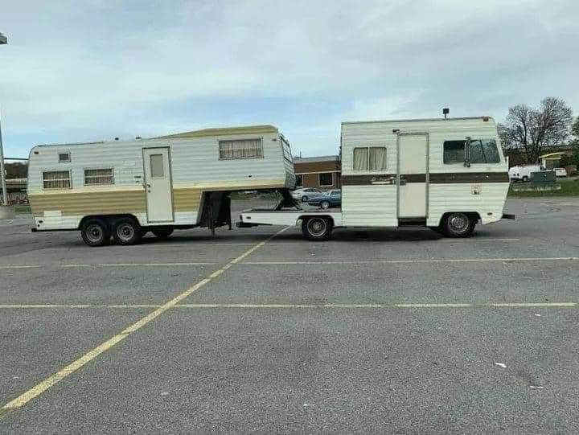

**From**

**Patricia Voyna**

**PO Box 1315**

**Conyers, GA 30012-1315**

**PST Newsletter – January 2024**

**IN GOD WE TRUST**



